**MySQL Project**

Inventory System Analysis

Master of Data Science & Analytics in AI

**Prepared By :-**

Dewang Tetambe

**Submitted to :**



**Itvedant Education Pvt. Ltd**

**(Andheri Branch)**

**Q1** Select products which are not ordered at all in ascending order of id. Show product Label, product id.

**SELECT `ProductLabel`, `id`**

**FROM `products`**

**WHERE `id` NOT IN (SELECT `ProductId` FROM `orders`)**

**ORDER BY `id`;**

*\*\*\*\*\* INSIGHTS \*\*\*\*\**

Here we get to know about the products which are not being order hence we can conclude that these products are loss making so they can be removed from the inventory or reduce their quantities or can be marketed better.

**Output :**

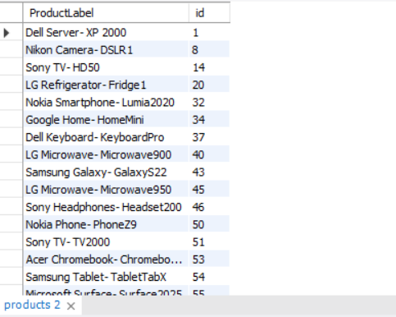

**Q2** Fetch top 5 most sold products in 2023. Show first name, last name, numbershipped, orderdate, productLabel.

**SELECT o.`First`, o.`Last`, o.`NumberShipped`, o.`OrderDate`, `ProductLabel`**

**FROM `orders` o JOIN `products` p**

**ON o.`ProductId` = p.`id`**

**WHERE YEAR(o.`OrderDate`) = 2023**

**ORDER BY `NumberShipped` DESC**

**LIMIT 5;**

*\*\*\*\*\* INSIGNTS \*\*\*\*\**

These are our top 5 valuable customers in the year 2023 along with the products they ordered. We can provide them some concession for the same products which will improve the product popularity as well as customer satisfaction.

**Output :**

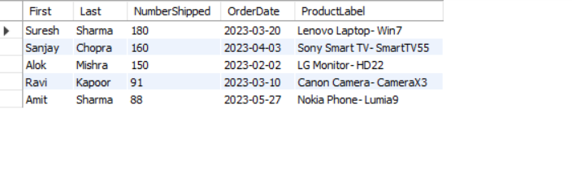

**Q3** Fetch top supplier of products. Show supplier and total number received.

**SELECT s.`id`, s.`supplier`, sum(p.`NumberReceived`) AS `totalQuantitySupplied`**

**FROM `suppliers` s JOIN `purchases` p**

**ON s.`id` = p.`SupplierId`**

**GROUP BY s.`supplier`, s.`id`**

**ORDER BY `totalQuantitySupplied` DESC**

LIMIT 1;

*\*\*\*\*\* INSIGNTS \*\*\*\*\**

We get our top supplier. This shows they are the most important business partner.

**Output :**

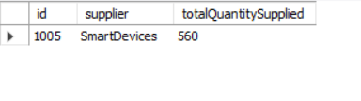

**Q4** Fetch all orders placed in Q2 of 2021 ordered by months. Show product label, date.

**SELECT p.`ProductLabel`, date_format(o.`OrderDate`, '%D %b, %Y') AS `Q2_Dates`**

**FROM `orders` o JOIN `products` p**

**ON o.`ProductId` = p.`id`**

**WHERE QUARTER(`OrderDate`) = 2 AND YEAR(`OrderDate`) = 2021**

**ORDER BY MONTH(`OrderDate`);**

*\*\*\*\*\* INSIGHTS \*\*\*\*\**

We got all products sold in quarter 2 i.e. Apr-June of 2021 as it was lockdown we got to know what products interested customers the most.

**Output :**

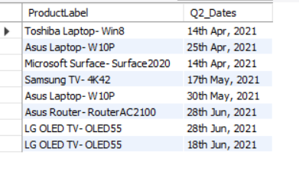

**Q5** Show all products purchaced in 2022 and 2023 from earliest to latest. Show products and number received, date.

**SELECT pd.`ProductLabel`, p.`NumberReceived`, date_format(`PurchaseDate`, '%D %b %Y') AS DATE**

**FROM `products` pd JOIN `purchases` p**

**ON pd.`Id` = p.`ProductId`**

**WHERE YEAR(`PurchaseDate`) IN (2022, 2023)**

**ORDER BY YEAR(`PurchaseDate`), MONTH(`PurchaseDate`);**

*\*\*\*\*\* INSIGHTS \*\*\*\*\**

We can see that the products purchased is showing a declining trend from 2022 to 2023.

**Output :**

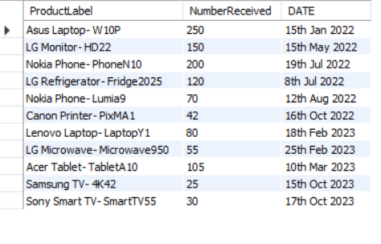

**Q6** Show Average no of products supplied by each supplier in descending order. Show supplier and no received.

**SELECT s.`supplier`, ROUND(AVG(p.`NumberReceived`), 2) AS `totalQuantityPurchases`**

**FROM `suppliers` s JOIN `purchases` p**

**ON s.`id` = p.`SupplierId`**

**GROUP BY s.`supplier`**

**ORDER BY `totalQuantityPurchases` DESC, s.`supplier`;**

*\*\*\*\*\* INSIGHTS \*\*\*\*\**

We can see that the average products supplied which shows importance of each supplier .

**Output :**

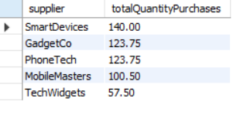

**Q7** Show Orders in FY2022-23 as top product as Best, Good, Low. Show product name, no shipped, top product.

**SELECT p.`ProductLabel`, o.`NumberShipped`,**

**CASE**

**WHEN `NumberShipped` >= 100 THEN 'Best'**

**WHEN `NumberShipped` >= 50 THEN 'Good'**

**WHEN `NumberShipped` > 0 THEN 'Least'**

**END AS `productRating`**

**FROM `orders` o JOIN `products` p**

**ON o.`ProductId` = p.`id`**

**WHERE `OrderDate` BETWEEN '2022-04-01' AND '2023-03-31'**

**ORDER BY `NumberShipped` DESC;**

*\*\*\*\*\* INSIGHTS \*\*\*\*\**

We can see the products sold in FY2022-23 and based on product rating the sales are overall balanced.

**Output :**

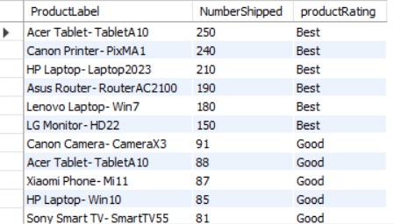

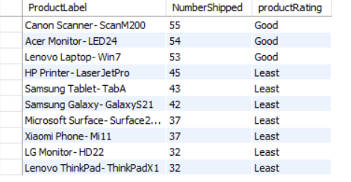

**Q8** Show 5 least purchaced in FY2022-23 as top purchases as Best, Good, Low. . Show product name, date, no of products received.

**SELECT pd.`ProductLabel`, p.`PurchaseDate`, p.`NumberReceived`,**

**CASE**

**WHEN `NumberReceived` >= 100 THEN 'High'**

**WHEN `NumberReceived` >= 50 THEN 'Good'**

**WHEN `NumberReceived` > 0 THEN 'Low'**

**END AS `purchaseRating`**

**FROM `products` pd JOIN `purchases` p**

**ON pd.`id` = p.`ProductId`**

**WHERE p.`PurchaseDate` BETWEEN '2022-04-01' AND '2023-03-31'**

**ORDER BY `NumberReceived`**

**LIMIT 5;**

*\*\*\*\*\* INSIGHTS \*\*\*\*\**

We can see the least purchased in FY2022-23 as we can see from the purchase rating the purchasing power is strong.

**Output :**

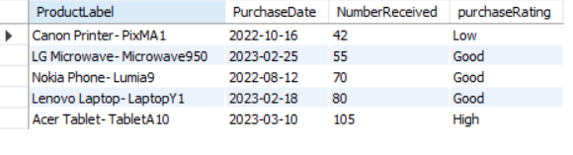

**Q9** Show all the LG, Nokia and Asus products purchased and their quantity.

**SELECT pd.`ProductLabel`, p.`NumberReceived`,**

**CASE**

**WHEN `NumberReceived` >= 100 THEN 'High'**

**WHEN `NumberReceived` >= 50 THEN 'Good'**

**WHEN `NumberReceived` > 0 THEN 'Low'**

**END AS `purchaseRating`**

**FROM `products` pd JOIN `purchases` p**

**ON pd.`id` = p.`ProductId`**

**WHERE `ProductLabel` REGEXP '^lg|^nokia|^asus'**

**ORDER BY `ProductLabel`;**

*\*\*\*\*\* INSIGHTS \*\*\*\*\**

Hence purchases made for both these products is good based on purchase rating.

**Output :**

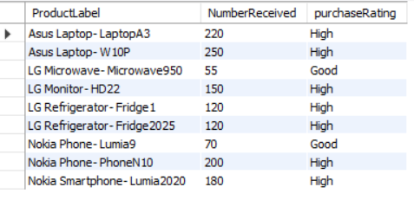

**Q10** Show total sales made in the year 2020 and 2021 for each product type.

SELECT P.`ProductName`, sum(O.`NumberShipped`) as `totalShipped`

FROM `orders` o JOIN `products` p

ON o.`ProductId` = p.`id`

WHERE YEAR(O.`OrderDate`) IN (2020, 2021)

GROUP BY `ProductName`

ORDER BY `totalShipped` DESC;

*\*\*\*\*\* INSIGHTS \*\*\*\*\**

Sales made for each product shows important types.

**Output :**

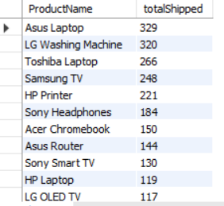

**Q11** Show highest selling product in each month in the year 2022. Name, month, no.

**SELECT p.`ProductLabel`, `NumberShipped` AS `MaxNumberShipped`, date_format(o.`OrderDate`, '%b') AS `date(2022)`**

**FROM `orders` o JOIN `products` p**

**ON o.`ProductId` = p.`id`**

**WHERE YEAR(`OrderDate`) = 2022 AND**

**`NumberShipped` IN (SELECT MAX(`NumberShipped`) FROM `ORDERS`**

**WHERE YEAR(`orderdate`) = 2022**

**GROUP BY MONTH(`OrderDate`))**

**ORDER BY MONTH(`OrderDate`);**

*\*\*\*\*\* INSIGHTS \*\*\*\*\**

By knowing the most sold product in each month we can focus on improving marketing for products of same type for that particular month.

**Output :**

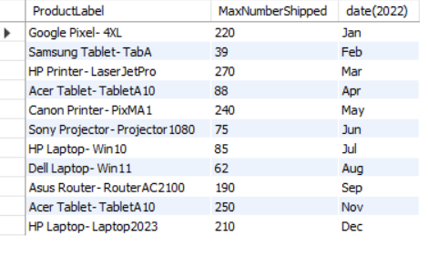

**Q12** Show all products and total no of orders shipped, most sold order and order count for each product type ordered by product name.

**SELECT p.`ProductName`, SUM(`NumberShipped`) AS `TotalShippment`, max(`NumberShipped`) AS `MaxPerOrder`, count(`NumberShipped`) AS `OrdersPlaced`**

**FROM `products` p LEFT JOIN `orders` o**

**ON o.`ProductId` = p.`id`**

**GROUP BY p.`ProductName`**

**ORDER BY P.`ProductName`;**

*\*\*\*\*\* INSIGHTS \*\*\*\*\**

Shows sales details for each products as well as those products which were not sold at all so their supply can be considered in the future to prevent losses.

**Output :**

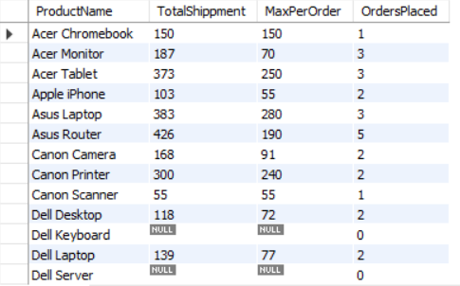

**Q13** Show product's current inventory which is highest order placed at a time.

**SELECT `InventoryOnHand`, id,ProductLabel FROM `products`**

**where `id` in (SELECT `ProductId` FROM `orders` where**

**`NumberShipped` = (SELECT MAX(`NumberShipped`) FROM `orders`));**

*\*\*\*\*\* INSIGHTS \*\*\*\*\**

We get to know the current stock of products ordered in bulk hence it lets us decide to stockpile those products.

**Output :**

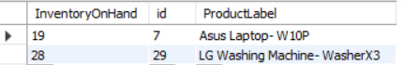

**Q14** Show all laptops and their stocks in the products table and their sales made.

**SELECT p.`ProductLabel`, p.`InventoryOnHand`, SUM(o.`NumberShipped`) AS `TotalSales`**

**FROM `products` p JOIN `orders` o**

**ON o.`ProductId` = p.`id`**

**WHERE p.`ProductLabel` LIKE '%laptop%'**

**GROUP BY p.`ProductLabel`, p.`InventoryOnHand`**

**ORDER BY `TotalSales` DESC;**

*\*\*\*\*\* INSIGHTS \*\*\*\*\**

Sales and current stock of all laptops are shown which gives which laptop is popular.

**Output :**

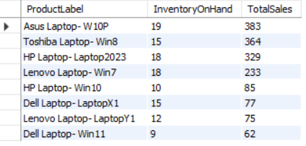

**Q15** Product with inventory on hand more than 20 and not ordered at all.

**SELECT `InventoryOnHand`, `ProductLabel`**

**FROM `products`**

**WHERE `id` NOT IN (SELECT `ProductId` FROM `orders`) AND**

**`InventoryOnHand` > 20;**

*\*\*\*\*\* INSIGHTS \*\*\*\*\**

Here unordered products with inventory in bulk can either be sold for a discount to reduce losses.

**Output :**

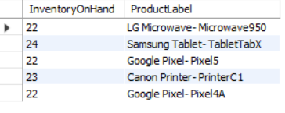

**Q16** Show names of the people concatenated with initial of Middle name who placed orders in 2021 order from higher no. shipped.

**SELECT CONCAT(`First`, " ", LEFT(`Middle`, 1), ". ", `Last`) AS `Name`,**

**SUM(`NumberShipped`) AS `OrderSize`**

**FROM `orders` WHERE YEAR(`OrderDate`) = 2021**

**GROUP BY `Name`**

**ORDER BY `OrderSize` DESC;**

*\*\*\*\*\* INSIGHTS \*\*\*\*\**

Full names of customers who ordered in 2021 showing important customers based on order size.

**Output :**

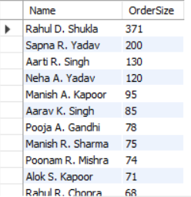

**Q17** Show all cameras and TVs starting inventory of products where inventory on hand more than 15.

**SELECT `ProductLabel`, `InventoryOnHand` FROM `products`**

**WHERE `ProductLabel` REGEXP 'camera|tv' AND**

**`InventoryOnHand` > 15;**

*\*\*\*\*\* INSIGHTS \*\*\*\*\**

Current inventories of cameras and TVs which has good stock quantity.

**Output :**

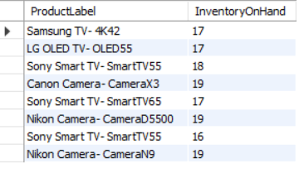

**Q18** No of products supplied for all quarters of 2022 by suppliers.

**SELECT SUM(`NumberReceived`) AS `TotalPurchases`, CONCAT("Q", QUARTER(`PurchaseDate`), " ", YEAR(`PurchaseDate`)) AS `quarter`**

**FROM `purchases`**

**WHERE YEAR(`PurchaseDate`) = 2022**

**GROUP BY QUARTER(`PurchaseDate`), `quarter`;**

*\*\*\*\*\* INSIGHTS \*\*\*\*\**

It shows the trends of each quarter in 2022 where purchase size was increased or decreased.

**Output :**

